1. [5 marks]

Write a function that returns the sum of all the elements in a specified column in a matrix using the following header:

const int SIZE = 4;

double sumColumn(const double m[][SIZE], int rowSize,

int columnIndex);

Write a test program that reads a 3-by-4 matrix and displays the sum of each column.

Sample Run

Enter a 3-by-4 matrix row by row:

1.5 2 3 4

5.5 6 7 8

9.5 1 3 1

Sum of the elements at column 0 is 16.5

Sum of the elements at column 1 is 9

Sum of the elements at column 2 is 13

Sum of the elements at column 3 is 13

Filename: AS1_1_yourstudentid.cpp

1. [5 marks]

9 coins are placed in a 3 × 3 matrix with some face up and some face down. You can represent the state of the coins using a 3 × 3 matrix with values 0 (head) and 1 (tail).

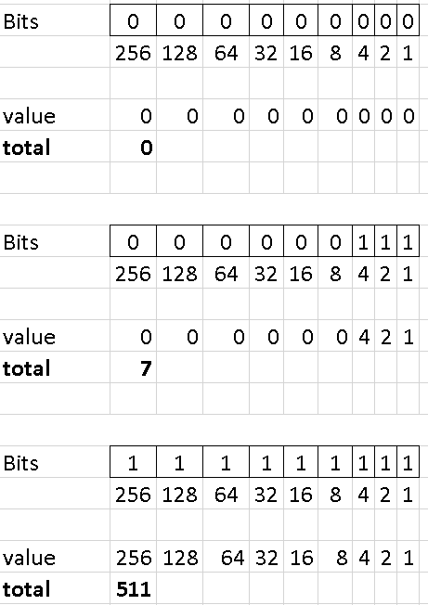

Here are some examples:

0 0 0 1 0 1 1 1 0 1 0 1 1 0 0

0 1 0 0 0 1 1 0 0 1 1 0 1 1 1

0 0 0 1 0 0 0 0 1 1 0 0 1 1 0

Each state can also be represented using a binary number.

The total number of possibilities is 512. So you can use decimal numbers 0,1, 2 , 3, . . . , and 511 to represent all states of the matrix.

Write a program that prompts the user to enter a number between 0 and 511 and displays the corresponding matrix with characters H and T.

Sample Run

Enter a number between 0 and 511: 7

H H H

H H H

T T T

The user entered 7, which corresponds to 000000111. Since 0 stands for H and 1 for T, the output is correct.

Filename: AS1_2_yourstudentid.cpp